# **Name: Abdurrahman Qureshi**

# **Roll No: 210451**

Practical No: 2

**1) Write a Program to print whether the number is Even or Odd using if else statement.**

**CODE:**

<!doctype html>  
<html lang="en">  
<head>  
 <meta charset="UTF-8">  
 <meta name="viewport"  
 content="width=device-width, user-scalable=no, initial-scale=1.0, maximum-scale=1.0, minimum-scale=1.0">  
 <meta http-equiv="X-UA-Compatible" content="ie=edge">  
 <title>Document</title>  
 <?php  
 $numK = 15;  
 function WBPEXP2($numK): bool  
 {  
 if ($numK % 2 == 0)  
 {  
 return true;  
 } else {  
 return false;  
 }  
 }  
 $check = WBPEXP2($numK);  
 if ($check) {  
 echo $numK . " is and Even Number";  
 } else {  
 echo $numK . " is and Odd Number";  
 }  
 ?>  
</head>  
<body>  
  
</body>  
</html>

**OUTPUT:**

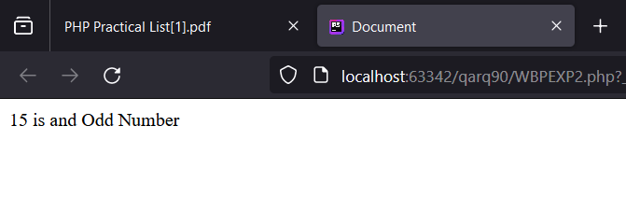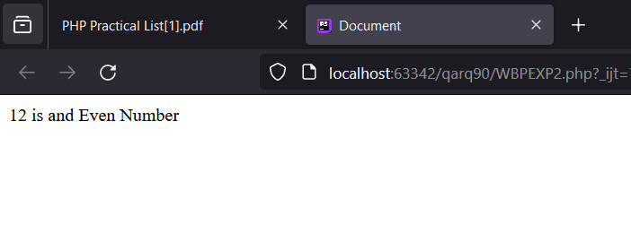

**2) Write a Program to print whether the character is Vowel or not using else if ladder.**

**CODE:**

<!doctype html>  
<html lang="en">  
<head>  
 <meta charset="UTF-8">  
 <meta name="viewport"  
 content="width=device-width, user-scalable=no, initial-scale=1.0, maximum-scale=1.0, minimum-scale=1.0">  
 <meta http-equiv="X-UA-Compatible" content="ie=edge">  
 <title>Document</title>  
 <?php  
 $numK = "z";  
 function WBPEXP2($numK): bool  
 {  
 if ($numK == "a" || $numK == "A") {  
 return true;  
 } else if ($numK == "E" || $numK == "e") {  
 return true;  
 } else if ($numK == "i" || $numK == "I") {  
 return true;  
 } else if ($numK == "o" || $numK == "O") {  
 return true;  
 } else if ($numK == "u" || $numK == "U") {  
 return true;  
 } else {  
 return false;  
 }  
 }  
 $check = WBPEXP2($numK);  
 if ($check) {  
 echo $numK . " is a vowel";  
 } else {  
 echo $numK . " is a consonant";  
 }  
 ?>  
</head>  
<body>  
  
</body>  
</html>

**OUTPUT:**

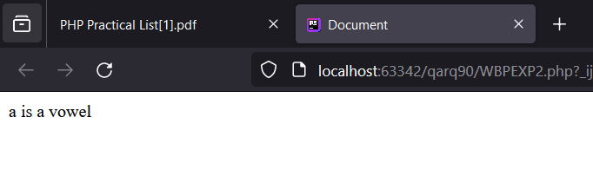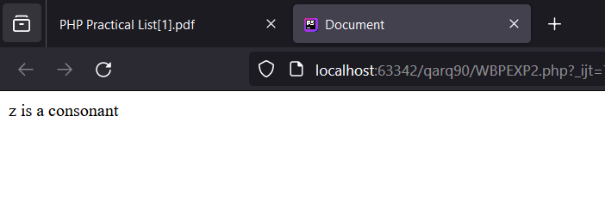

**3) Write a Program to print the greatest of three numbers using nested if else.**

**CODE:**

<!doctype html>  
<html lang="en">  
<head>  
 <meta charset="UTF-8">  
 <meta name="viewport"  
 content="width=device-width, user-scalable=no, initial-scale=1.0, maximum-scale=1.0, minimum-scale=1.0">  
 <meta http-equiv="X-UA-Compatible" content="ie=edge">  
 <title>Document</title>  
 <?php  
 $numI = 30;  
 $numJ = 500;  
 $numK = 100;  
 function WPBEXP2($numI, $numJ, $numK): int  
 {  
 if ($numI > $numJ) {  
 if ($numI > $numK) {  
 return $numI;  
 } elseif ($numJ > $numK) {  
 return $numJ;  
 }  
 } else {  
 return $numK;  
 }  
 }  
 $greatestNumber = WPBEXP2($numI, $numJ, $numK);  
 echo "The greatest number among $numI, $numJ, and $numK is: $greatestNumber";  
 ?>  
</head>  
<body>  
  
</body>  
</html>

**OUTPUT:**

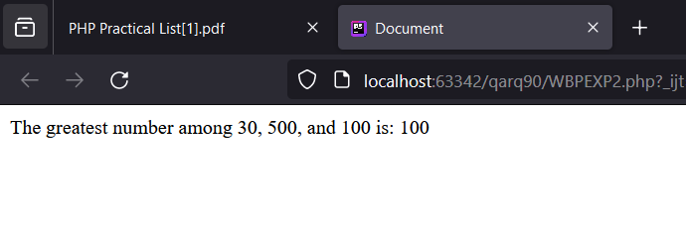

**4) Write a Program to print whether the year is the Leap Year or not using if else statement.**

**CODE:**

<!doctype html>  
<html lang="en">  
<head>  
 <meta charset="UTF-8">  
 <meta name="viewport"  
 content="width=device-width, user-scalable=no, initial-scale=1.0, maximum-scale=1.0, minimum-scale=1.0">  
 <meta http-equiv="X-UA-Compatible" content="ie=edge">  
 <title>Document</title>  
 <?php  
 $year = 2021;  
 function WBPEXP2($year): bool  
 {  
 if (($year % 4 == 0 && $year % 100 != 0) || ($year % 400 == 0)) {  
 return true;  
 } else {  
 return false;  
 }  
 }  
 $check = WBPEXP2($year);  
 if ($check) {  
 echo $year . " is a leap year";  
 } else {  
 echo $year . " is not a leap year";  
 }  
 ?>  
</head>  
<body>  
  
</body>

</html>

**OUTPUT:**

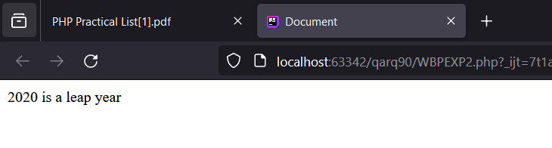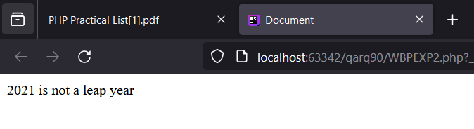

**5) Write a Program to print the Day of the Week using Switch Statement.**

**CODE:**

<!doctype html>  
<html lang="en">  
<head>  
 <meta charset="UTF-8">  
 <meta name="viewport"  
 content="width=device-width, user-scalable=no, initial-scale=1.0, maximum-scale=1.0, minimum-scale=1.0">  
 <meta http-equiv="X-UA-Compatible" content="ie=edge">  
 <title>Document</title>  
 <?php  
 $year = "Thursday";  
 function WBPEXP2($year): string  
 {  
 switch ($year) {  
 case "Monday":  
 return "Monday";  
 break;  
 case "Tuesday":  
 return "Tuesday";  
 break;  
 case "Wednesday":  
 return "Wednesday";  
 break;  
 case "Thursday":  
 return "Thursday";  
 break;  
 case "Friday":  
 return "Friday";  
 break;  
 case "Saturday":  
 return "Saturday";  
 break;  
 case "Sunday":  
 return "Sunday";  
 break;  
 default:  
 return "Invalid Day";  
 break;  
 }  
 }  
 $check = WBPEXP2($year);  
 echo "Day of the week: " . $check;  
 ?>  
</head>  
<body>  
</body>  
</html>

**OUTPUT:**

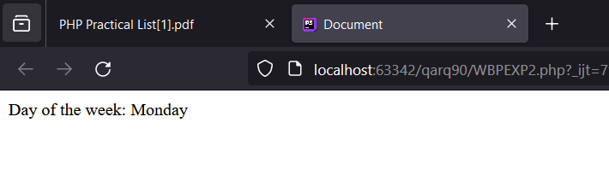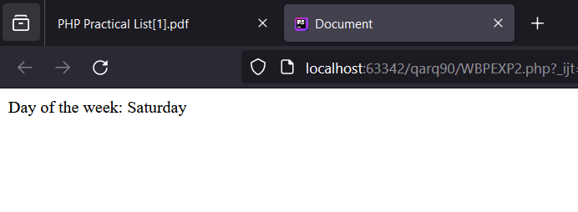

**6) Write a Program to print the Month of the Year using Switch Statement.**

**CODE:**

<!doctype html>  
<html lang="en">  
<head>  
 <meta charset="UTF-8">  
 <meta name="viewport"  
 content="width=device-width, user-scalable=no, initial-scale=1.0, maximum-scale=1.0, minimum-scale=1.0">  
 <meta http-equiv="X-UA-Compatible" content="ie=edge">  
 <title>Document</title>  
 <?php  
 $monthNumber = 5;  
 function WBPEXP2($monthNumber): string  
 {  
 switch ($monthNumber) {  
 case 1:  
 return "January";  
 break;  
 case 2:  
 return "February";  
 break;  
 case 3:  
 return "March";  
 break;  
 case 4:  
 return "April";  
 break;  
 case 5:  
 return "May";  
 break;  
 case 6:  
 return "June";  
 break;  
 case 7:  
 return "July";  
 break;  
 case 8:  
 return "August";  
 break;  
 case 9:  
 return "September";  
 break;  
 case 10:  
 return "October";  
 break;  
 case 11:  
 return "November";  
 break;  
 case 12:  
 return "December";  
 break;  
 default:  
 return "Invalid Month";  
 break;  
 }  
 }  
 $check = WBPEXP2($monthNumber);  
 echo "Month: " . $check;  
 ?>  
</head>  
<body>  
</body>

**OUTPUT:**

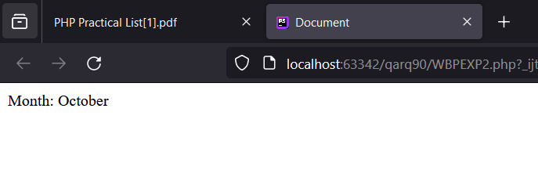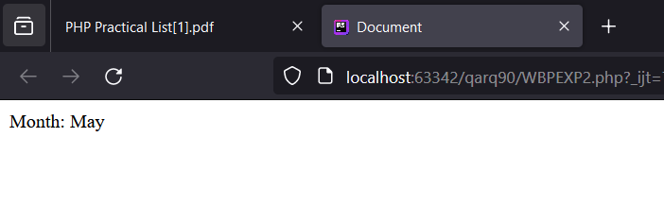

**7) WAP to print whether it is a Vowel or not using Switch Statement.**

**CODE:**

<!DOCTYPE html>  
<html lang="en">  
<head>  
 <meta charset="UTF-8">  
 <meta name="viewport" content="width=device-width, user-scalable=no, initial-scale=1.0, maximum-scale=1.0, minimum-scale=1.0">  
 <meta http-equiv="X-UA-Compatible" content="ie=edge">  
 <title>Document</title>  
 <?php  
 $vowel = "A";  
 function WBPEXP2($vowel): void  
 {  
 switch (strtolower($vowel)) {  
 case "e":  
 case "i":  
 case "u":  
 case "o":  
 case "a":  
 echo $vowel . " is a vowel";  
 break;  
 default:  
 echo $vowel . " is a consonant";  
 break;  
 }  
 }  
 WBPEXP2($vowel);  
 ?>  
</head>  
<body>  
  
</body>  
</html>

**OUTPUT:**

